**CODING CONVENTIONS**

**1.Code Layout:**

* **Indentation**

The syntactical elements of the code are indented according to the nesting level.

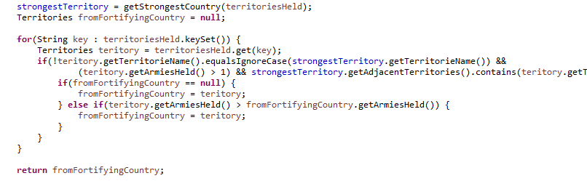

* **Method Indentation**

The body of the methods are indented with respect to its function header with a space after declaration.

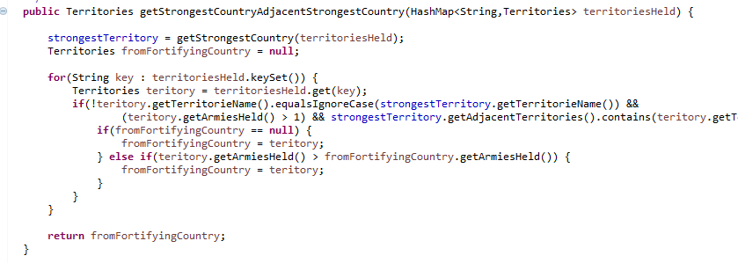

* **Statement Format**

The open curly braces are appended to the statement that proceeds it.

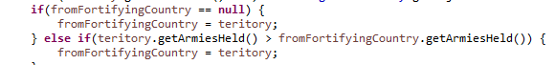

* **Blank Lines**

Blank Lines are inserted between method definitions, class declarations and sections of long and complicated code to enhance readability.

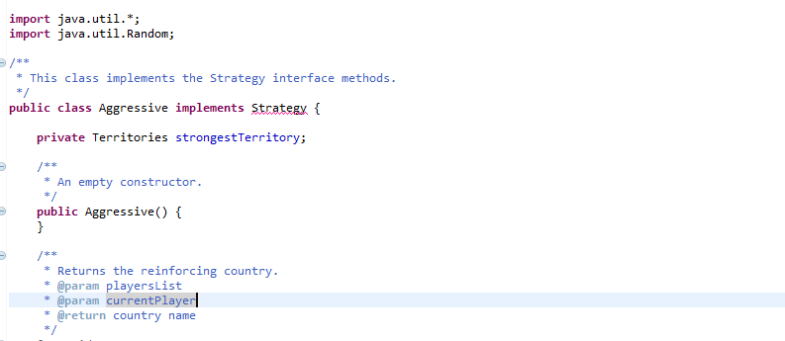

**2. Naming Conventions**

* **Class Names**

Class names follow camel case. The class names begin with capital letter and if the names contain multiple words, each word is separated by capital letter at the beginning of each word.



* **Method Names**

Method Names begin with lower case letter and if there’re multiple words, upper case letters are used to separate them.



* **Constants**

The constants will be denoted with upper case letters.



* **Local Variables**

The local variables begin with capital letter and if the names contain multiple words, each word is separated by capital letter at the beginning of each word.



**3. Commenting Conventions**

* Comments precede all class declaration that describes the purpose of the class. These comments are used to generate Javadoc.

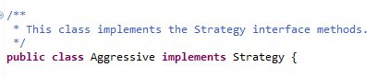

* All the methods have comments describing their role and their parameters names.

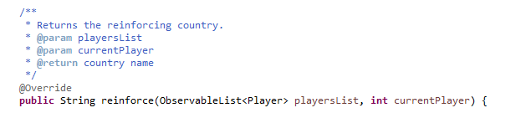

**4.Exception Handling**

Format of try and catch statements is as seen in the picture below:

